Tournament Details

Anticipated to be a 1:30 shotgun start (pending Covid restrictions)
Registration:
Cost: $125 per player
Format: 4-person scramble

Contests will include:
Putting Contest
Circle Hole Competition
Hole in One Contests
Raffle/Auction

The Auburn Rotary Foundation
The Auburn Rotary Foundation is the charitable arm of the Rotary Club of Auburn. Over the years the Foundation has participated in many projects including:
- Providing over $1,200,000 in scholarships for students at Auburn’s High Schools and Green River College
- Raised funds to build a dental clinic in Kenya
- Raised funds to build the Water Park at Les Gove Park in Auburn
- Participates in Rotary International’s project “End Polio Now”
- Started “Partners For Work” a project designed to create work opportunities for those with developmental disabilities
- Participates in “Rotary First Harvest” matching excess produce from regional farmers with local food banks
- Established a local water source for a village in Uganda
The Object of Rotary
The Object of Rotary is to encourage and foster the ideal of service as a basis of worthy enterprise and, in particular, to encourage and foster:
- FIRST - The development of acquaintance as an opportunity for service;
- SECOND - High ethical standards in business and professions; the recognition of the worthiness of all useful occupations; and the dignifying of each Rotarian's occupation as an opportunity to serve society;
- THIRD - The application of the ideal of service in each Rotarian's personal, business, and community life;
- FOURTH - The advancement of international understanding, goodwill, and peace through a world fellowship of business and professional persons united in the ideal of service.

About Auburn Rotary
The Rotary Club of Auburn is an organization, chartered in 1957, of 60 business and professional men and women who provide humanitarian services, encourage high ethical standards in all vocations, and help build goodwill and peace in the world. We are members of Rotary International District 5030, which is part of Rotary International, a worldwide organization that has approximately 1.2 million Rotarians with more than 30,000 Rotary clubs in 161 countries.
We meet every Wednesday at the Auburn Golf Course from noon to 1:15. Come join us!
www.auburnrotary.org
Auburn Rotary
Earl Averill Memorial Golf Tournament

Friday, September 10, 2021
1:30 Start
Auburn Golf Course

A 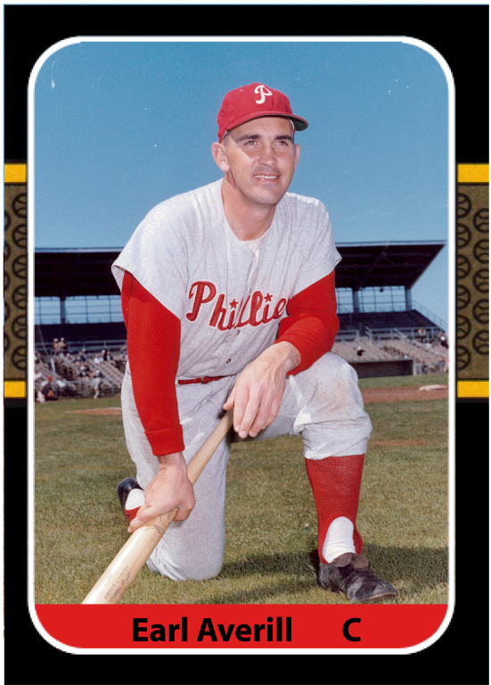

Auburn Golf Course
29630 Green River Road
Auburn WA
www.auburngolf.com

Become a Tournament Sponsor!

Available Sponsorships

Gold Sponsor (Up to Two) $2,500
Muckleshoot Casino
Includes: Custom listing on all promotional banners and printed materials. Signage on major contest hole in one contest and/or other prominent placement. Premium hole signage and listing on tournament information sheets. Includes a foursome for golf.
Box Lunch Meal/Cart Sponsor $2,000
Includes: Prominent listing on promotional banners and printed materials. Signage on every golf cart, signage on one hole and listing on tournament information sheets. Includes one foursome for golf.
Silver Sponsor $1,000
Includes: Prominent listing on promotional banners and printed materials. Signage on an "on-course" contest, signage on one hole and listing on tournament information sheets. Includes one foursome for golf
Bronze Sponsor $500
Includes: Signage on an "on-course" contest hole, listing on printed materials, signage on one hole and listing on tournament information sheets.
Hole Sponsor $250
Includes: Signage on one hole and listing on tournament information sheets.

Sponsor Name:
Please check the above sponsor level
Email your company logo, in EPS (vector) format to: dfaber@auburnwa.gov

All CDC Guidelines that are in place on the tournament date will be followed:

Social Distancing-Be a good sport and be consideration of others by social distancing
Food-Great meal supplied by Bogies Restaurant. We will provide water and other goodies in the swag bag.
Golf-All Health Department and State if Washington regulations are abided by and enforced by the Auburn Golf Course

Payment options:
- Register online at auburnrotary.org
- Pay by check payable to Auburn Rotary
- Pay by Credit Card
Credit Card #
Exp. Date (MM/YY)________ CVV: ________
Name on Card:
Billing Address:
Amount to Charge:
Signature:
Sponsorship payment is not available on-line
Please Email your completed form to:
dfaber@auburnwa.gov

Or mail your form to:
Auburn Rotary Golf Tournament
910 Ninth Street
Auburn, WA 98002
Attn. Daryl Faber
Golfer Registration

Golfer #1:
Phone:
Email:

Golfer #2:
Phone:
Email:

Golfer #3:
Phone:
Email:

Golfer #4:
Phone:
Email:

Scramble Format

Cost: $125 per player, includes lunch, 10 raffle tickets, entry into on course games, 2 Mulligans and an afternoon of fun

